# Media Analysis - No need to demonize ChatGPT but AI regulation is a must

## Short Summary

The article centers around ChatGPT's role in revolutionizing journalism, education potentially aiding cheating , posing job threats to journalists and writers particularly in medical fields, while acknowledging concerns about creativity, ethics, and its equalizing potential under proper regulation.

## Summary

1. **ChatGPT's Emergence**: ChatGPT, developed by OpenAI, is a large language model capable of understanding and responding to natural language, causing significant advancements in technology and journalism.  
2. **Impact on Journalism**: ChatGPT has revolutionized the way news is produced and consumed in Saudi Arabia, with its ability to write essays, articles, research papers, reports, poetry, and explain complex subjects in simple language.  
3. **Education's Concerns**: Universities and schools are grappling with potential cheating and plagiarism issues as ChatGPT is being used by students to generate assignments without studying the material thoroughly.  
4. **AI in Education Transformation**: Educational institutions are adapting by shifting towards more interactive teaching methods, such as oral exams, handwritten tests, and nuanced questions that AI cannot comprehend.  
5. **Threat to Journalists and Writers**: Some news sites experimented with AI to publish articles, raising concerns about the role of journalists and original content, despite ChatGPT's performance being comparable to human-authored works.  
6. **AI in Medical Field Threats**: ChatGPT has shown potential for medical professionals by passing the US Medical Licensing Examination, though there are ongoing debates about whether it could replace doctors entirely.  
7. **AI and Literature Ethical Implications**: AI is used to generate children's books in California, raising ethical issues related to creativity, copyright protection, and protests from artists against AI-generated art. Despite limitations such as occasional mistakes, nuanced prompts confusion, and outdated information, ChatGPT remains a promising tool that could provide opportunities for those lacking resources in science fields.  
8. **Need for Regulations**: Without appropriate regulations, the hype surrounding AI's threats to human jobs may overstate potential negative consequences, while its benefits as an equalizer can be maximized with careful supervision and guidelines.

## Question 1:

How do the media in this article frame the public discussion about ChatGPT? Are there certain **metaphors** that keep cropping up?

The media frames the public discussion about ChatGPT with a combination of fascination 'breathtaking capacity', 'a great opportunity for advancement' and caution using metaphors like 'existential threat' to express concerns regarding job displacement .

## Question 2:

Which role does or might the Arabic World play in the development of Artificial Intelligence? Answer with 'Not mentioned' if not applicable.

Not applicable

## Question 3:

Which use cases of Artificial Intelligence are helpful for the Arabic world based on this article?

The article highlights AI's potential use cases in journalism, particularly through ChatGPT. This tool enables quick generation of detailed content, including essays, articles, research papers, reports, poetry, and explanations on complex scientific topics, potentially transforming news production in the Arabic world.

## Question 4:

What is the final message of the article that the author wants to convey? Keep your answer short and precise!

The author conveys that AI, specifically ChatGPT, offers both potential benefits and challenges. While it could replace jobs in certain fields like journalism and healthcare without proper safeguards, it also has the capacity to level the playing field in scientific research for developing nations if regulated effectively.

## Sentiment

The sentiment is <0>

The article discusses both the potential benefits and challenges posed by ChatGPT and Artificial Intelligence (AI). It highlights how AI can revolutionize journalism, education, medicine, and even creative fields like literature, offering significant opportunities for advancement. However, it also points out various concerns such as job displacement in sectors like journalism and writing, potential misuse of AI-generated content leading to plagiarism, and ethical issues related to AI's role in areas like education and creativity. Despite these challenges, the article argues for a balanced approach where AI is seen as an equalizer rather than an existential threat, particularly in developing countries with limited resources for research. It emphasizes the need for regulations to ensure that AI benefits society without causing harm. Overall, the sentiment of this text is cautiously optimistic about AI and ChatGPT, acknowledging their potential while also being aware of the issues they might bring.

## Entities

Seattle Public School System Quickly Ban University College Fear Ban Ineffective Raise Question Academic Freedom Busy Try Contain Chatgpt Potentially Negative Impact Education Change Mode Instruction Give Oral Exam Handwritten, Washington Post Article Write Chatgpt See Lucid Different Write Human Post Consider Experiment Journalistic Disaster, Chatgpt Midjourney Ai Program, Newsroom, New York Times, Accord Axios Chatgpt, Https Medium Arab News Country, New Technology Chatgpt View, Amal Mudallali

## Topic Clusters

### Cluster: Advancements and Impact on Education

ChatGPT advancements, educational transformation

## Word Clouds

### Wordcloud of content

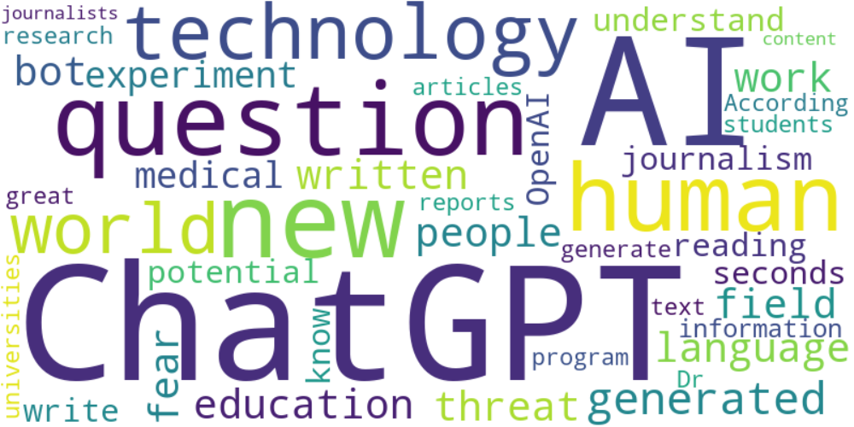

Top 10 words:

- ChatGPT: 27  
- AI: 24  
- human: 7  
- technology: 6  
- news: 5  
- world: 5  
- generated: 5  
- field: 4  
- language: 4  
- written: 4

### Wordcloud of summary

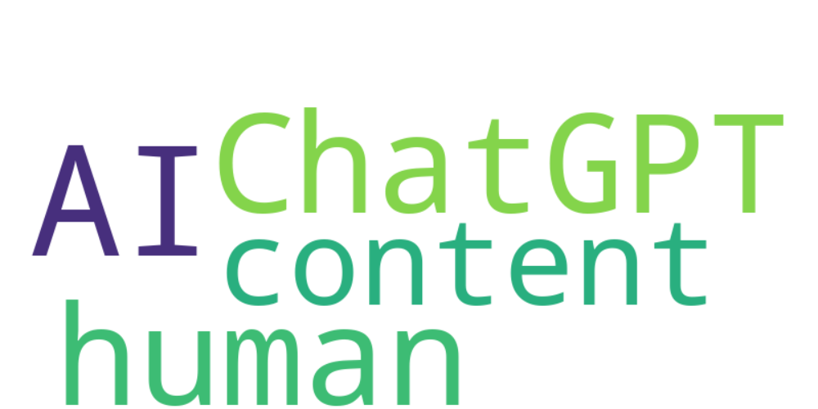

Top 10 words:

- AI: 8  
- ChatGPT: 7  
- language: 3  
- potential: 3